R7Lite Brief
Top View
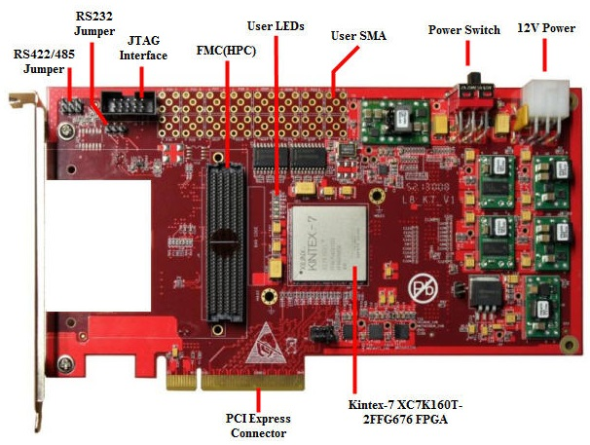
Bottom View

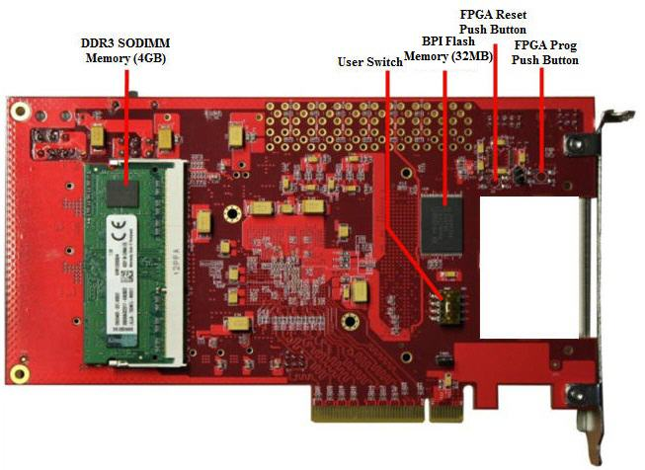

Key Features
- FPGA
- Kintex-7 XC7K160T-2FFG676（support 160T、325T、410T）
- Configuration
- JTAG header provided for use with Xilinx download cables such as the Platform Cable USB II
- 32MB（256Mbit）BPI Flash
- Memory
- DDR3 SODIMM Memory
- 256Mbit BPI Flash
- Communication
- RS232 Header
- RS422/485 Header
- PCI Express x8 edge connector
- 16 SMA connectors
- GTX port (TX, RX) for FMC-HPC connector
- Expansion Connectors
- FMC-HPC (Partial Population) connector (4 GTX Transceiver, 116 single-ended or 58 differential (34 LA & 24 HA) user defined signals)
- Vadj can support 1.8V, 2.5V, or 3.3V
- IIC
- Clocking
- Fixed Oscillator with 50MHz output
- Fixed Oscillator with differential 200MHz output
- Differential SMA clock input
- Differential SMA GTX reference clock input（implement on FMC Mezzanine.
- Display
- 4x LEDs
- Control & I/O
- 4x DIP Switches
- Diff Pair I/O (16 SMA pairs)
- 2x 12V FAN Header
- Power
- 12V wall adapter or ATX

R7Lite and Daughter card FMC_ADA Connection
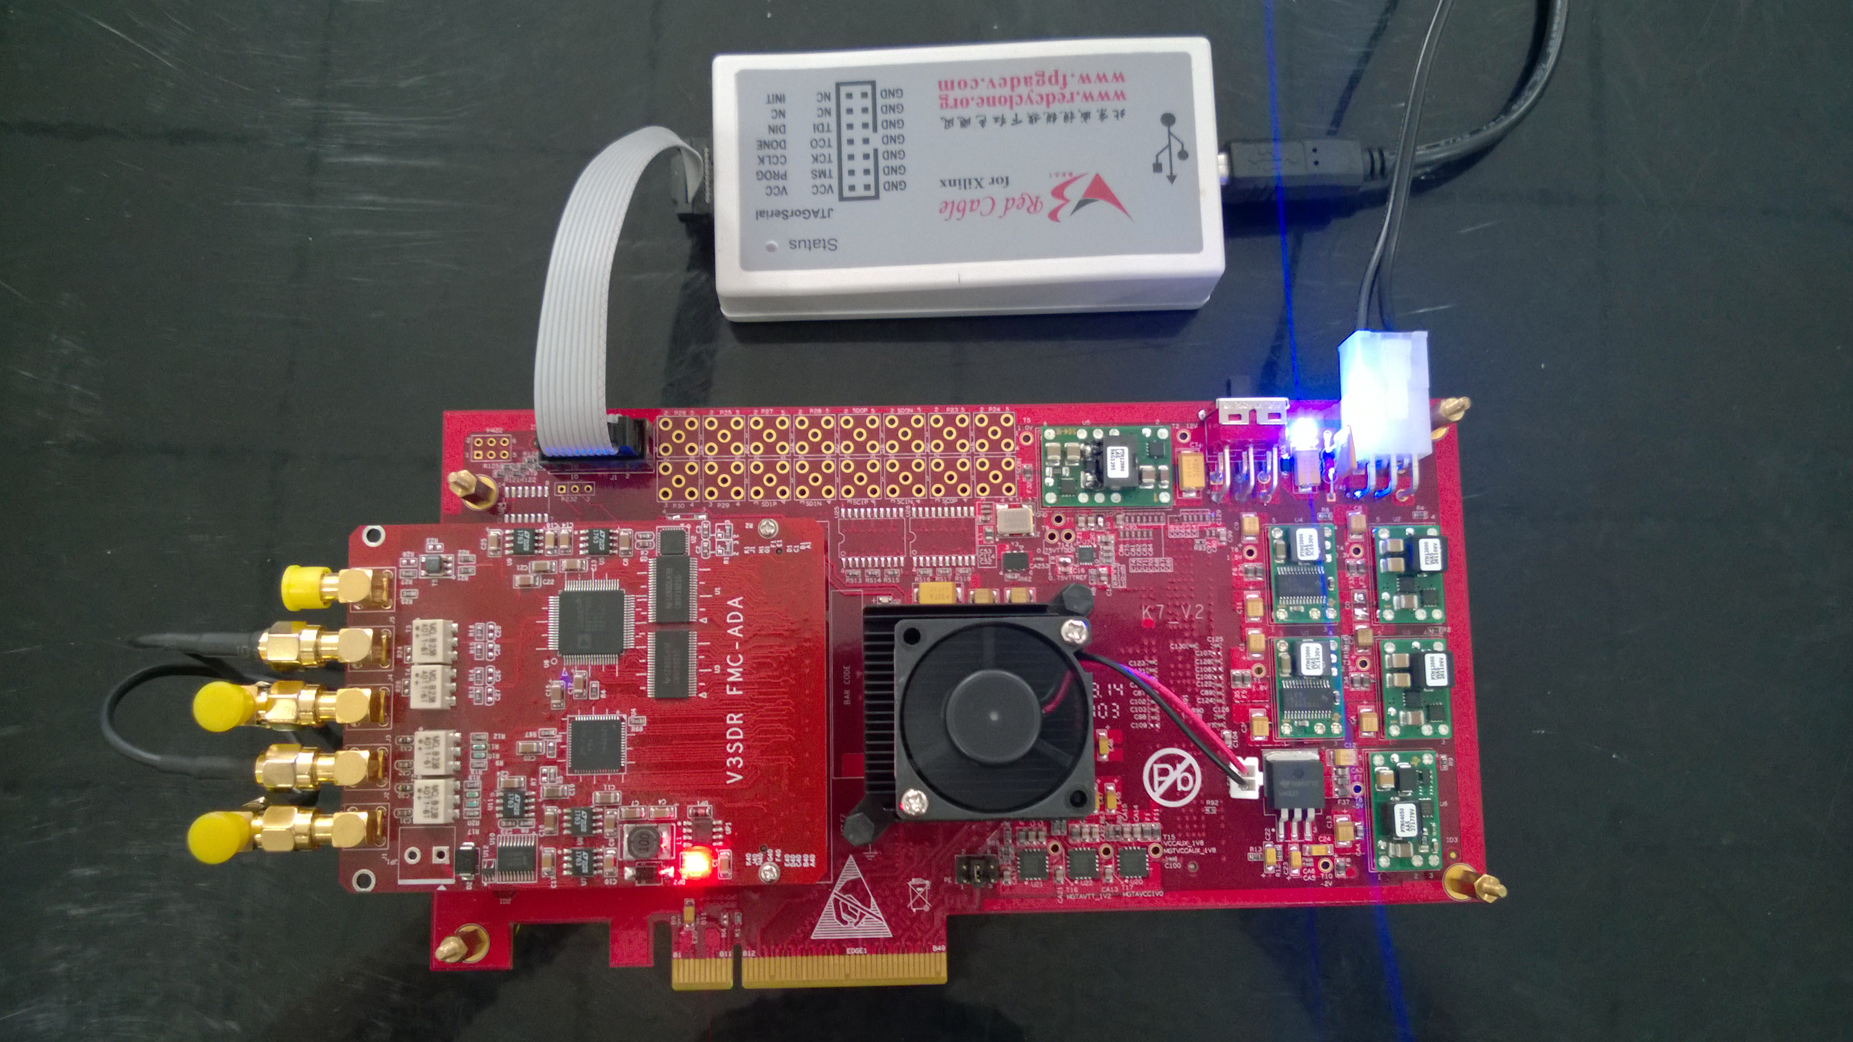

Two ways to Power Up
- PCIE interface from PC: switch SW1 to Right side;
- External 12V power source：switch SW1 to Left side;

Three kind of Voltage to power FMC Vadj
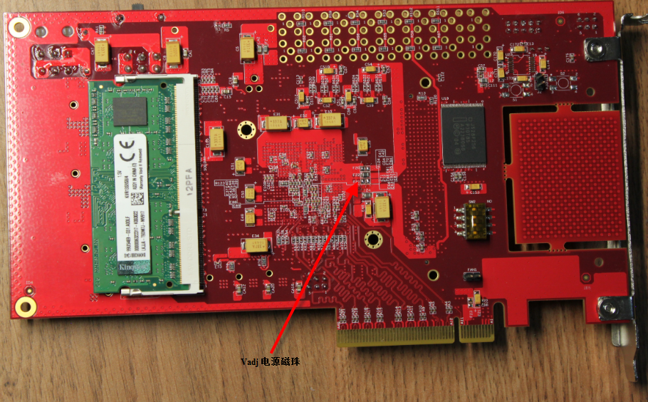
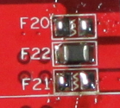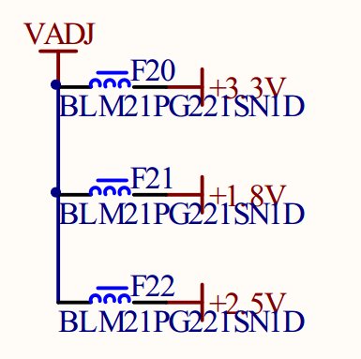
F20:3.3V F21:1.8V F22:2.5V（default）

